“From Millet Land to Maize Land”
Report on a Visit to
Better Soils/Imagine Afrika’s Program in Malawi
January 30 to February 9, 2020
By Roland Bunch

The Situation in the Drought-Prone Areas of Sub-Saharan Africa
Put very briefly, about half of sub-Saharan Africa’s agricultural and grazing lands have been going through a process of serious degradation for the last 40 years. Starting in about the 1980s, population pressure on the land has forced farmers to gradually decrease the time they fallowed their land (ie allowed forests to grow on the land in order to replenish its natural fertility) from about 15 years to ten years, then four years, and then two years. Today, fallowing is in its death throes across most of Africa.
This has meant, in turn, that the organic matter content of the soil has dropped from about 4% to less than 1%, and the rainfall infiltration rate into the soil has dropped from about 60% in the 1980s to between 10 and 20% today. Unbeknownst to most people, this is the primary cause, rather than climate change, of Africa’s droughts, which are rapidly increasing both in intensity and frequency (from about one every ten years up until the 1980s to one every second or third year today).
As a result, Africa’s basic grain yields are decreasing, and farmers are finding in many areas that they only get a decent maize crop two or three out of every five years. In desperation, they have turned to growing sorghum (which is more resistant to drought and poor soils than is maize), and in some areas, to millet (which is even more drought-resistant). The vast majority of Africans greatly prefer to eat maize, but they are making these changes out of desperation.
Mozambique, because of its higher population rates along the coast, started this process in about the 1960s—20 years before most of the rest of Africa. As a result, people in most of Mozambique cannot grow maize, sorghum or millet, but rather are now eating primarily cassava roots, which have very little nutritional value at all. The result is that the child stunting rate in Mozambique is now well above 70% in the rural areas, which puts it among the three or four most malnourished nations in the world. Basically, most of a whole generation of Mozambique’s children will grow up having less mental and physical capacity than they would have had they been eating anywhere near properly.
And that is the direction the rest of drought-prone Africa is headed.
The Imagine Afrika Program’s History and Technology
Catholic Relief Services (CRS) began working with green manure/cover crops (gm/ccs) in its UBALE Program in southern Malawi back in the mid-2010s. Gm/ccs include any plants, even trees, that do a good job of fertilizing the soil or controlling weeds. CRS, working with the author of this report in a series of consultancies, found that gliricidia trees (Gliricidia sepium) and pigeon peas were the most appropriate for the area among half-a-dozen high-potential species, and began spreading them among the farmers throughout the Program area. At the beginning of 2019, the funding for the UBALE Program was unexpectedly terminated, so it ended prematurely, and two of its top leaders decided to establish a small local NGO, Imagine Afrika (IA), to try to continue UBALE’s work. With the support of Better Soils, Better Lives (of which this author is the CEO), IA is now covering about half of the area previously covered by the UBALE program, with hopes of expanding to cover the whole area in the next year or two.
The gliricidia trees are being used primarily to produce gliricidia leaves, which are an extremely

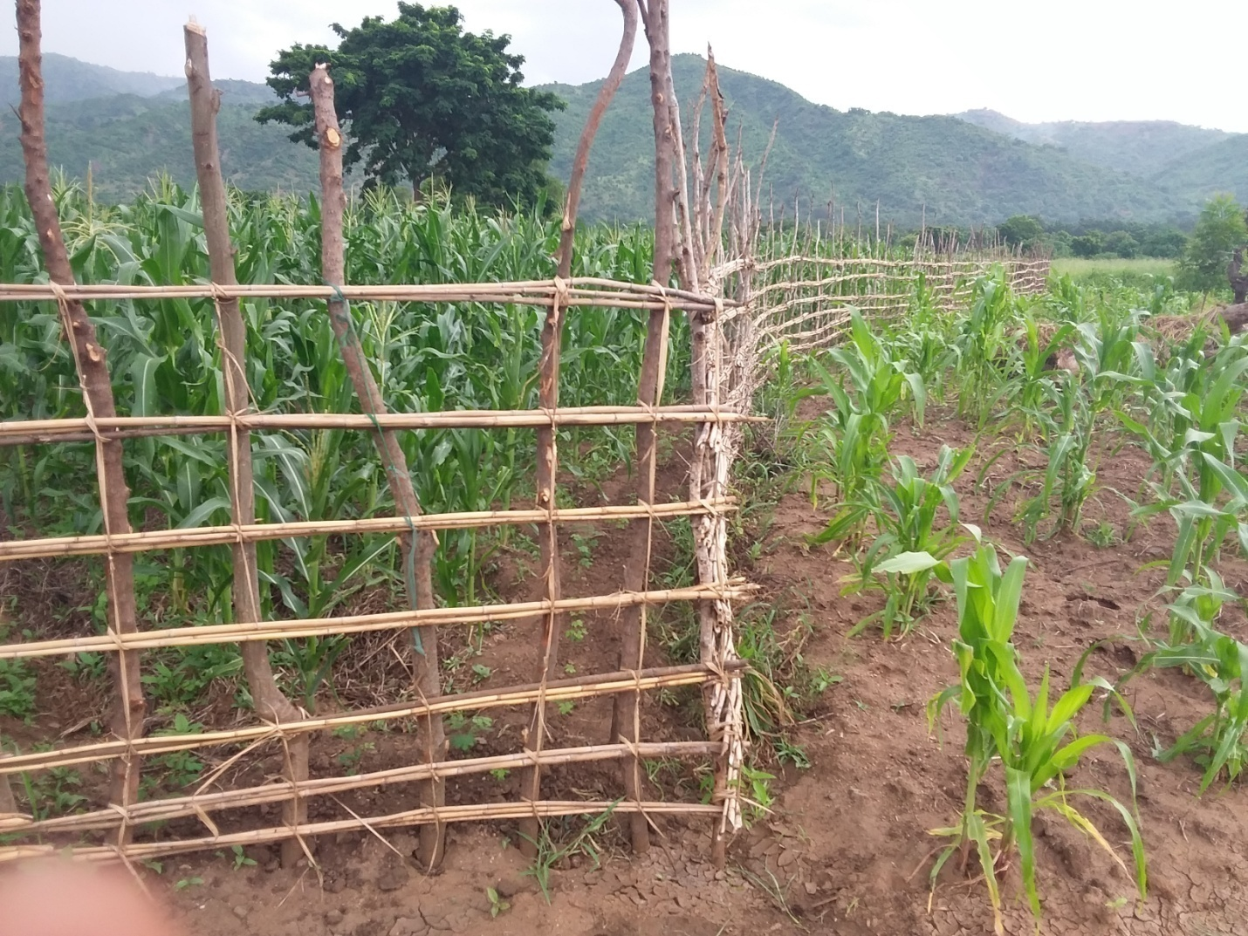
The only difference between this lead farmer’s dark green maize inside the fence and the stunted yellow maize outside it is that she is using gliricidia leaves (from trees still too short to see in the tall maize) to fertilize the maize inside the fence. Both fields were planted the same day. The line of very small plants just inside the fence is the beginnings of a monkey thorn fence that will replace, within a year, the much more laborious and less effective fence in the photo. The new fence will also provide firewood, promoting the protection of the forest, rather than require the cutting of hundreds of tree branches from the forest every year, as the older fence does.
good fertilizer, and to provide shade to the crops, which in the lowland tropics suffer from too much heat and from the soil’s drying out too quickly. This same shade will also protect their crops in the future as global warming heats up the environment. Gliricidia trees are very fast-growing—producing medium-sized trees in four or five years—and can very easily be pruned with a machete while one is standing on the ground, so they will not produce excessive shade. They are also a multi-purpose species, providing plentiful dry season cattle and goat fodder, firewood, human food (the flowers) and even a very effective rat poison (in the bark).
The second gm/cc species IA is promoting is the pigeon pea, an edible, high-protein legume that also fertilizes the soil extremely well, can be sold in local markets, and can be intercropped with the maize and gliricidia. Furthermore, other legumes, such as cowpeas, common beans, and green gram, can be planted beneath the pigeon pea and gliricidia, to provide a fourth edible crop and a third gm/cc (once enough shade is provided by the gliricidia to keep the nitrogen and biomass of the fourth legume from being burned off the field). Meanwhile, the maize (or sorghum or millet) will gradually come to produce even more grain/ha than it did previously as a monocrop.
A third species of plant being propagated, also pioneered by UBALE its last year or two, is the monkey thorn tree (Acacia galpini), which is an excellent species for fencing off agricultural land. In this climate, most gm/ccs must be able to grow through the dry season, in order to avoid losing most of their nitrogen and part of their biomass to the lowland tropical heat. Therefore, they need to continue growing throughout the 6- to 7-month dry season. Since we also want our gm/ccs to be edible, so they provide high-protein food for farm families, they are nearly always edible by animals, and therefore likely to be consumed during the dry season by free-grazing cattle and goats. Farmers have tried to make fences from local trees or thorn bushes, but these fences require a tremendous amount of work to rebuild each year, and most of them still let the cattle through when they get hungry enough to lean against the fences and push them over. On the other hand, within one year of planting, the monkey thorn tree is strong enough and thorny enough to keep cattle and goats out of a field. It requires only a simple pruning once a year, and, according to local elders, will last for from 80 to 100 years!
Even though we are selling this seed at cost (about US $ 4.00/kg, which can make about 1,000 mt of fence), farmers were pleading with us to get more seed. In order to find out just how popular it is, I asked one group of farmers what we should do if the program was really low on money—should we quit selling monkey thorn seeds or gliricidia cuttings? Their answer was quickly summed up by one farmer: “Don’t even ask us that question: we need them both!”
The Imagine Afrika Program This Last Year
Working through 50 well-motivated “lead farmers,” most of whom were trained by UBALE, the IA Program is expanding the use of gliricidia trees in farmers’ fields at a tremendous clip. The number of trees planted in farmers’ fields (ie not counting those planted alongside roads or as live fences) during this last 12 months is well over 20,000 trees, which means it has surpassed the total number of trees planted in fields in this area over the last six years. The lead farmers have planted, on average, about 200 trees in their own fields this year, while two of the star leaders planted more than one thousand trees each. And each of these 50 lead farmers has somewhere between 5 and 63 farmer trainees, far more than half of whom have each planted
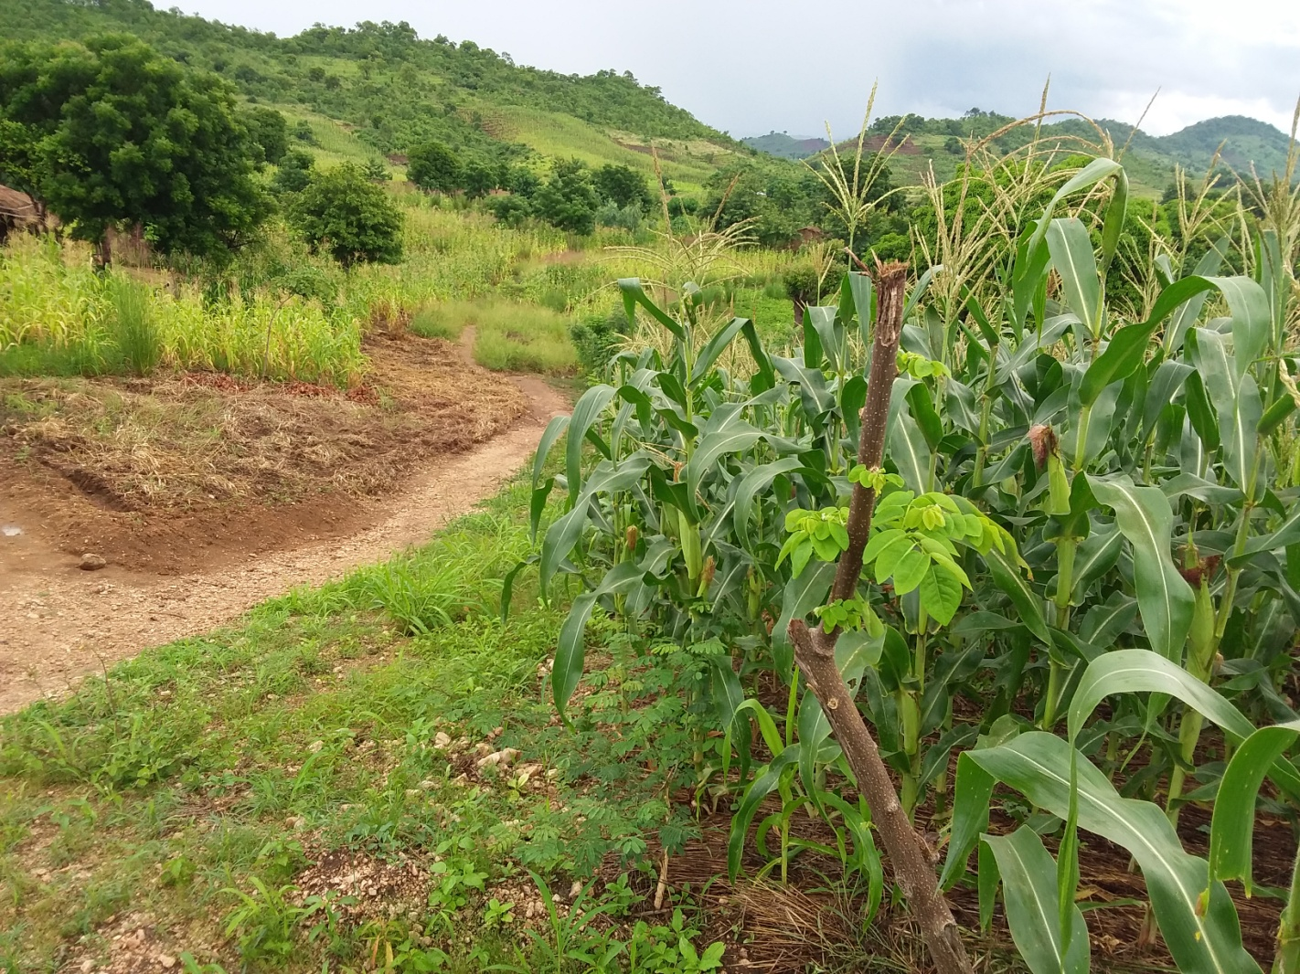
A gliricidia tree planted recently as a cutting is growing in front of this dark green, productive maize field amidst a sea of stunted, yellow maize and sorghum. The lead farmer in this village, a student of one of the 50 lead farmers trained by the UBALE Program, is one of the new generation of lead farmers being trained by the IA Program. He already has this impressive demo plot, right next to the village’s main trail, to show his neighbors what they, too, can accomplish.

somewhere between 15 and 200 trees in their fields. And this is despite the natural inclination of African farmers not to have any shade in their fields.
In field after field, we saw situations like those in the accompanying photos, where tall green maize was growing within a few feet of stunted yellow maize barely over knee-high. Just under 15,000 of these gliricidia trees were grown from seedlings or cuttings produced or gathered by the Program, while the rest were produced from seedlings or cuttings gathered or produced by the farmers themselves. Even some of the first-year trainees we met have established their own seedbeds, with no Program encouragement, to produce gliricidia seedlings for themselves and their friends.
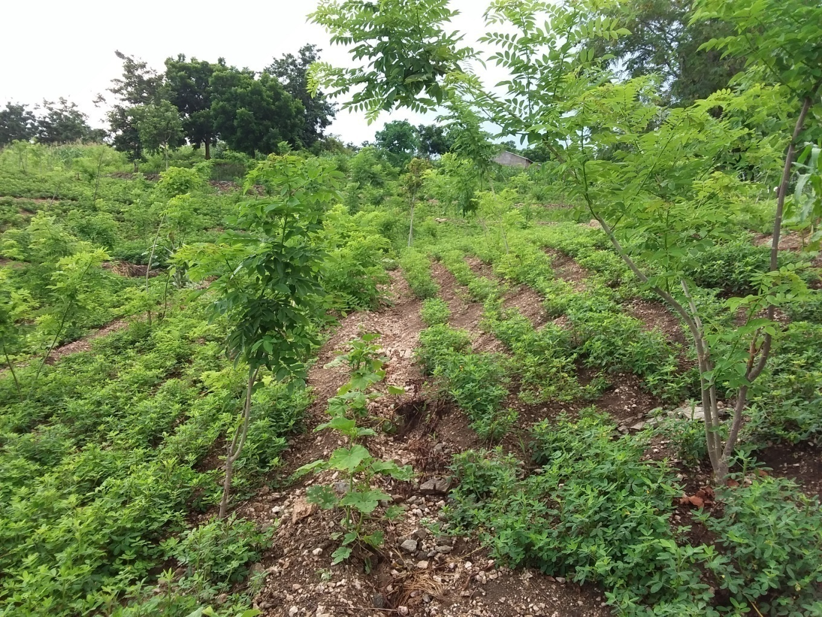
A photo of part of a typical field of one of the 50 lead farmers, which shows some 25 young gliricidia trees starting to provide shade and fertilizer for a crop of peanuts.

The monkey thorn tree hasn’t been left far behind. The biggest problem in propagating the monkey thorn tree is that the tree does not produce much seed, and it is not native to this part of Malawi. Therefore, the Program bought 50 kg of the seed in Lilongwe, Malawi’s capital, and all but two or three kg of that seed has been sold, with farmers demanding more. The Program will buy another 50 kg of seed this coming week, to be distributed to the lead farmers, who in turn sell it to the others. (The Program would buy more, but this last batch of seeds will all have to be planted within the next three or four weeks in order to receive enough rain to survive the approaching dry season.)
Actually, the fact that this tree does not produce very much seed is one of the advantages it has over other potential species of live fence in the area: it will not become invasive. And while 50 kg does not sound like very much, it is enough to create approximately 50,000 mt of fencing (ie 50 km, equal to about 30 miles), depending on the rate at which it is sown.
Not everything in the Program area is perfect. The area’s farmers have shown through their experiments that the population of gliricidia trees, which UBALE originally advised should be

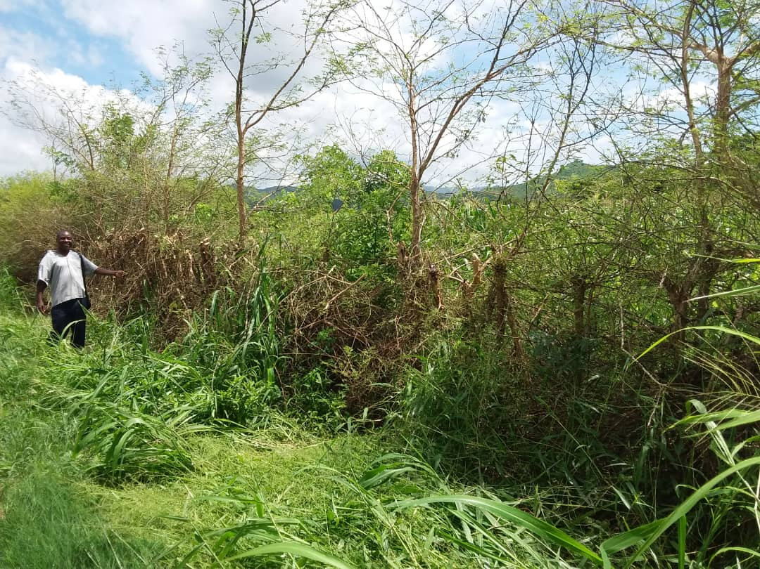
This section of a monkey thorn fence has been recently trimmed, but the farmer has left some vertical branches in hopes of eventually harvesting some seeds for future expansion of the fence. This sort of farmer experimentation is one of the factors required to achieve the sustainability of a program’s work. Trimming is the only work that will be required to keep it functioning for at least the next 80 years. It will incur no cash costs whatsoever. Notice also the tall, healthy maize inside the fence.

planted at 5 by 5 mt, is too small to maximize the impact on fertility. The farmers’ soils, and maize, are doing better in fields where there is a spacing of about 3 mt by 5 mt—about 65% more than the recommended population of trees. So we will either need to convince a lot of farmers to plant the trees more densely in their fields, or get the pigeon peas and under-sown legumes to the point of producing the extra biomass.
We also found out during this visit that the pigeon pea has had problems with termite attacks, so very little of it is now being planted. We will try out several simple, non-toxic solutions to this problem. This lack of pigeon peas has, in turn, resulted in very few of the pigeon peas’ being ratooned (cut off about 50 cm above the ground at the end of the year, rather than being killed and reseeded). Ratooning will not only result in farmers’ being able to fertilize the soil with green leaves, but makes the plant almost totally resistant to drought, because of its having a year-old root system (or 2- or 3-year-old root system) right from the start of the rainy season, rather than starting from scratch as they do when grown from seed. Therefore, we will have to continue promoting the ratooning of the pigeon peas.
Also, the farmers here seem to have a much stronger fear of shading out their crops than do farmers in most of Africa. They have almost all pruned their gliricidia so that only a few vertical branches are left, and have planted their intercrops at only one plant/sq mt rather than three or four. Because of this, the biomass produced is much less than it should be, and the shade frequently non-existent. This can very likely be overcome by some good demo plots with adequate shade.
Of course, the high level of credibility the Program has gained among the farmers with the very popular success of the gliricidia and monkey thorn fences will make all of these needed improvements a good deal easier to achieve.
Still, in spite of these technological defects, the over-all level of farmer enthusiasm is incredible. Farmer after farmer proudly showed us that his or her sorghum and millet were easily producing double what they had before. In a good number of fields, farmers showed us that they could now grow maize, after five or ten years of only being able to grow sorghum, or even millet. There were even the beginning signs of drought-resistance in many of the fields--something we usually don’t see until after four or five years of significant soil improvement.
If we can maintain anywhere near this level of multiplication of our efforts, with each lead farmer training an average of 15 others, and some of those 15 farmers training 10 or 15 more (and also assuming we can raise the money to expand our program as planned and work with other NGOs such as the FMNR movement), we will definitely be able to reach our target of ending hunger among 70% of sub-Saharan Africa’s farmers before the year 2045. Of course, the larger a program gets, the more difficult it becomes to maintain the level of enthusiasm that this Program now has, but this start is certainly encouraging.
As we were climbing into our car to leave the last farmer we visited during this week of beautiful surprises, the farmer happily summed up the results of his work this year:
“We used to have to eat sorghum. Now we can eat maize again!”

