CASE STUDIES OF REGENERATIVE AGRICULTURE
By Roland Bunch
October 2017 (Revised April 2020)

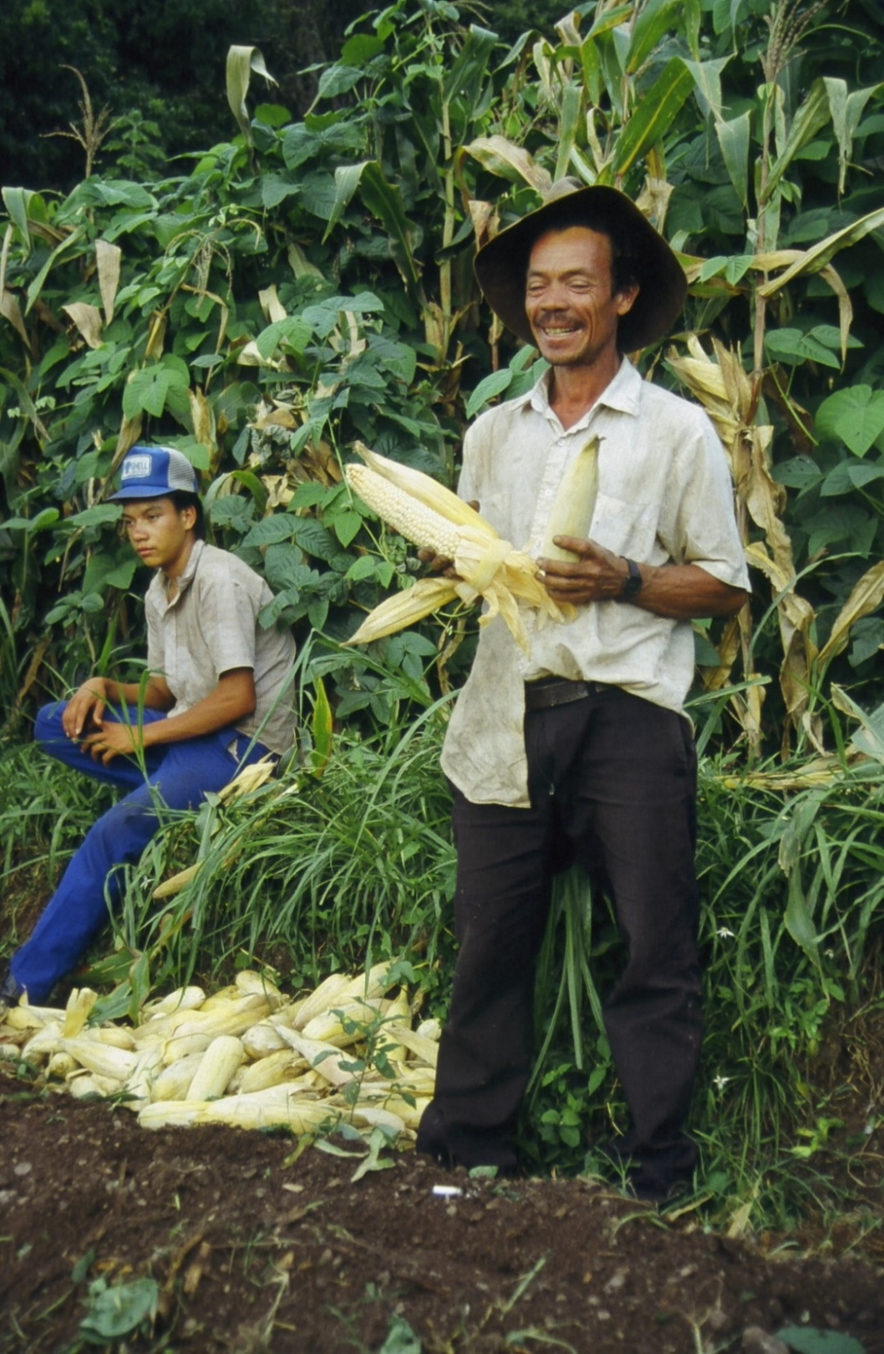

In order to better understand the impact of what has been happening to the literally millions of smallholder farmers using regenerative agriculture across the developing world, let’s first look at the impact it has had on a single, more or less average farmer among all those more than 15 million farmers around the world using regenerative agriculture. Laureano, pictured above, is showing us the nature and results of his switch to “regenerative agriculture.” (RA) Why has Laureano begun practicing RA? Frankly, it’s because it provides him with an impressive list of benefits. But one of the many beauties of RA is that by the very act of benefiting the individual farmer in multitudinous ways, it also benefits all of humankind in multitudinous ways. Contrary to what so often happens in human life, there is, in RA, no contradiction between the individual welfare of the producer and the general welfare of humankind.

So what are these benefits for Laureano, and what is Laureano doing to achieve them?

First and foremost, Laureano wants to have enough food to feed his family. That is the highest priority goal of virtually all smallholder farmers in any developing country, be she or he a Mayan from Guatemala, a Quechua from Bolivia, a Luo from Kenya or a Tai person from Vietnam. Laureano is showing us in his left hand one medium-sized ear of maize, like those he used to harvest four or five years ago from each of his maize plants. In his right hand, he has two large ears of maize, which is what he now harvests, on average, from each plant. That means that he is now harvesting close to three times what he previously did. And that, in turn, means that his son and his grandchildren will never again have to go hungry. They will be able to go to high school and buy the simple medicines they need and maybe even, someday, buy a used pick-up to take their excess produce to market to get a better price.

Laureano used to have to work as a day laborer on a nearby sugarcane plantation every year. Not now, nor ever again. With that tripling of yields, he easily grows, on his own farm, far more food than his family needs. And now that he has soil fertile enough to grow most anything, and produces plenty of food, he is experimenting with several cash crops. That is, he will start feeding other Hondurans. In the process, he will add biodiversity to his farm, which will enrich the environment, reduce the concentration of pests, and make his farm even more profitable.

A second goal for Laureano and for most other farmers like him, is that he wants to do all this with his human dignity still intact. He doesn’t want hand-outs. He doesn’t want to stand in line waiting for a bowl of soup while his children stand behind him, realizing he’s incapable of fulfilling the one minimum responsibility of every parent in almost any culture--that of feeding his own family. He very much wants the satisfaction of knowing, at the end of the day, that what he has achieved in life, he has accomplished himself, without dependency, or, worst of all, having to beg.

One of the beauties of RA as described below is that there is no need for hand-outs because there is nothing to hand out—at least, nothing beyond a handful of seed for an initial experiment. And giving someone a handful of seed in a village is not charity; it’s just a normal, everyday act of friendship.

A third goal for Laureano is to contribute toward the reduction of climate change. You’d be surprised how many of the world’s villager farmers know about climate change. Have they been watching TV? Maybe. But hundreds of millions of Laureanos around the world know about climate change because they are living on the receiving end of it.

To give just one example, fifty years ago, the Laureanos of the world planted according to the calendar. Mayan farmers in Patzum, Guatemala, for instance, planted their maize on the 24th of June. If the rainy season hadn’t started by then, it would within a week or so. But today, in Patzum, it may start raining as early as the middle of May, or as late as early August. I don’t know of a single group of smallholder farmers anywhere in the world without irrigation who can now plant by the calendar.

Planting maize has become like playing the lottery. Sure, you just might win. But it’s far more likely you will plant your seed when it should start raining, and it won’t rain for a month, so you’ve lost all your seed. Or you wait for the rain, it starts, you plant your maize, and it stops again. Or you wait until you’re sure it’s going to keep on raining, and you wind up planting so late that the rainy season ends before your maize has produced any grain. And for many Laureanos in this world, some years it will rain so infrequently that no matter when you plant your maize, you won’t get a decent harvest. So they know something has changed, and none of them I know has any doubts that climate change is one of the causes.

Look at that rich, black soil at Laureano’s feet. It is black and soft because he has put tremendous amounts of organic matter back into the soil. Every ounce of that organic matter has carbon in it. That is, the same organic matter that has tripled his yields is sequestering carbon. He is putting carbon that makes up atmospheric CO2 back in the ground where it belongs—where nature stored it for millennia before it ever became part of the atmosphere.

Where did he get all that organic matter? It must have taken a lot of work for him to carry it all onto his field and spread it around. Well, no, he grew it right there where he would need it. See that weed growing up the maize behind him? That’s what we call a green manure/cover crop (gm/cc). It fixes more nitrogen than his crops will ever need, and produces about 60 t/ha (green weight) of organic matter that makes his soil soft and black and fertile. He doesn’t have to buy it, or compost it, or haul it anywhere, or spread it around his field, or even cut it down. He just plants it. When it dies, and he cuts down his maize stalks, it starts fertilizing his soil. It also keeps his soil well-covered so the sun doesn’t heat it up too much. Neither tropical soils nor tropical crops do well with all that heat.

Last, but far from least, Laureano doesn’t want all this just for himself. He wants it for his children and his grandchildren. In a word, he wants his farm to be sustainable. It will be. After all, tropical forests represent the height of sustainability. They have been producing huge amounts of organic matter for tens of millions of years. As Laureano continues to improve his soil, as he continues to increase his farm’s biodiversity, as he produces all that organic matter, as he keeps his soil covered (foresters call it a “litter layer,” agronomists call it a “mulch”), and as he adopts more of the practices described below, such as growing dispersed shade trees on his farm, his fields will look more and more like tropical forests. They will also function more and more like tropical forests.

Among other things, if Laureano’s farm is still going to retain its productivity a couple of generations from now, that rich black soil at his feet is going to have to stay there, rather than go running down the hillside every time it rains. See that grass growing right behind Laureano? That grass is part of a contour grass barrier that stops his topsoil from washing down the slope. In fact, Laureano’s son, Marcos, is sitting on the edge of a 40-cm high terrace made up entirely of the soil that the grass has already stopped after it had begun washing down the hillside.

Will Laureano actually achieve sustainability? Some gm/cc systems we use have been producing for well over 500 years. Marcos obviously believes they have achieved sustainability. After all, he is still living here in the village rather than off searching in Tegucigalpa for one of those almost non-existent jobs in the capital’s slums. Marcos is thereby showing by his actions that he believes his father’s farm will provide him and his own family with a decent living for at least another generation.

I started by saying that RA would benefit all of humankind. We will all benefit from the end of poverty and hunger in this world. There will be fewer poverty-related diseases that tend to travel on planes to everywhere else. There will be more moderate numbers of immigrants clamoring to reach Europe and the US, so there will be mutual benefit for and from those who do. We and our governments will be asked to provide fewer hand-outs for the victims of famines. Those of us in the developed world will also have the satisfaction of knowing that we live in a world with at least a little more economic justice. And when more of the sons of the world’s Laureanos are not crowding into those deathly slums, there will be less civil unrest and fewer youths growing up in the kind of environment that produces more terrorists per sq. km than any other on earth (except, perhaps, for jail cells).

Lastly, it turns out that the farmers and ranchers of the world could sequester all the carbon we need to take out of the atmosphere to keep our world safe. Even fairly simple gm/cc systems can sequester more than 5 t/ha/year of long-term carbon in a decent tropical soil. If all the world’s farmers and ranchers sequestered carbon at this rate, they would sequester over 75% of all the carbon need to meet the goals of the Paris Climate Accords. And what will it cost humanity to sequester all this carbon? A whole lot less than storing carbon in caves or subsidizing wind energy or spraying our atmosphere with anti-global-warming particles. In fact, it will cost nothing for the world’s Laureanos, because sequestering that carbon is a free by-product of his producing three times what he did before. So Laureano’s process of developing a sustainable life-style will result in the rest of us also enjoying a more sustainable life-style, without a global environmental catastrophe staring us in the face.

Of course, RA is not going to storm the world overnight. Nor will getting us there be totally free of cost. Some people are going to have to spend the next 25 years training a lot of Laureanos before we get there.

The process will cost each farmer only a few handfuls of seed to get started. No one has ever given Laureano any hand-outs, in spite of his being from a small village in Honduras, a country with a rate of rural malnutrition equal to that of most of sub-Saharan Africa. Furthermore, he is farming on what most farmers from the world’s North would consider a postage stamp of a farm. Yet in his case and in every case study below, farmers who have learned to use RA are spreading it to other farmers spontaneously—at no cost to anyone else.

The most positive news of these stories is that we trainers won’t be starting from scratch. There are already well over 15 million other Laureanos out there using RA. Here are the stories of about 7 million of them. I have selected some of these ten stories from among the many dozens I could tell because of the widespread impact they have achieved, while I have chosen others to give an idea of the tremendous variety of RA technologies that exist, and still others because they illustrate important points about RA or agricultural development in general.

Case # 1. The Dogon “intermittent shade,” Koro, Mali

It was November of 2011, during one of the worst droughts ever suffered even in Africa’s droughty Sahel region, just south of the encroaching Sahara Desert. It was harvest time, except that for hundreds of thousands of farmers all around us, there was not going to be any harvest. As we drove over 500 km northeast from the country’s capital to some villages near the town of Koro, virtually every field around us had not a single maize, sorghum or millet plant that would reach your waist.

But as we approached the villages at our destination, we started seeing a strange sight. In every field, there were about 80 to 100 trees/ha. Strangest of all, every one of them, of a dozen different species, was shaped in a funny inverted cone, like huge funnels from a kitchen. Furthermore, we could see the people were harvesting and hauling back to the village a bumper crop of millet and half a dozen other crops. Even I, with 50 years’ experience at improving smallholder farmer agriculture in 49 developing nations, had no idea what was going on. Yet here these people had somehow created a veritable oasis in the middle of a desert.

After we had said our elaborate, obligatory greetings, asking how everything was right down to the people’s cattle, I asked one of the Dogon leaders about those funny, funnel-shaped trees. Good teacher that he was, he started by asking me a question to illustrate his point: “What happens to crops that are planted right under a mango tree, with its dense foliage down close to the ground?”

“The crops die.”

“Why?”

“Because they never get any sunlight.”

“Exactly. But if most of a tree’s leaves are high off the ground, their shadow gradually moves across the field as the sun travels across the sky. That way, all the crops, even those right next to the tree trunk, get some good sunlight at least part of the day. And that way they all grow better.”

The Dogon people were using what we now call “intermittent shade.” Crops all over the lowland tropics produce as much as 40% better under a well-managed tree shade than if they have to withstand the full tropical sunlight all day long. This is because they cannot stand the excessive tropical heat. As a result, they just stop growing during several hours in the middle of the day. And, of course, with global warming, this problem is going to get worse in the near future.

An intermittent shade also reduces both the evaporation of moisture from the farmers’ soil and transpiration from their crops. All that moisture is thereby no longer being unproductively sucked out of the farmers’ soil. This means that during a drought, crops will produce a whole lot better under intermittent shade than out in constant, direct sunlight.

I had never seen a case of intermittent shade before that November day, because as far as I know after all my wanderings, the Dogon people invented it. This little known, often looked down on “tribe” from the middle of nowhere, has given the world an incredibly valuable technology we are now beginning to spread across the tropics. It will raise yields, but it will also provide firewood and fodder, so real forests don’t have to be cut down, and will help defend farmers on three continents, as well as all the rest of us, from global warming. Furthermore, the trees drop more of that much-needed organic matter on the soil to enrich it, which means more carbon is sequestered in the soil. And that is in addition to all the carbon that is sequestered in the trees themselves.

And what does all this cost? Just the labor of pruning the trees in that funny shape once a year. Except that trimming those trees will save African women the huge job of walking 3 kms to a forest to climb the trees to cut firewood and then haul it all the way back to the village. All in all,
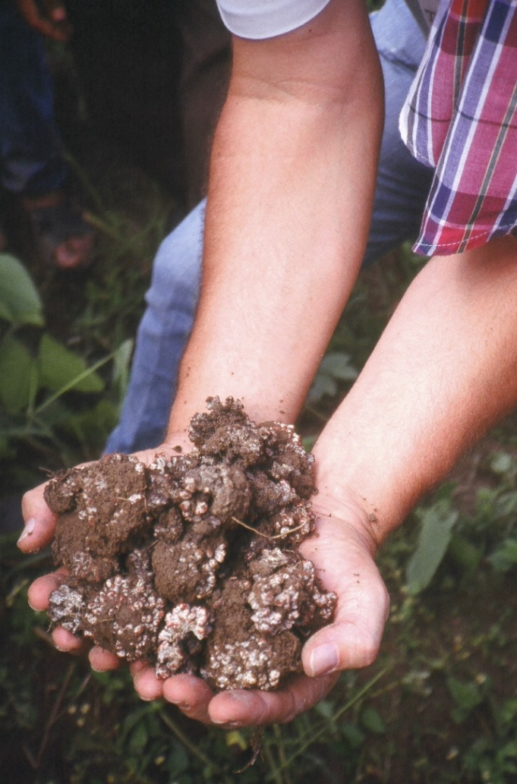
Most temperate country soils textbooks show photos of N-fixing nodules as tiny spheres of about 1 mm in diameter, well-spaced along a root. Quite obviously, tropical legumes that fix anywhere from 80 to 400 kg/ha of pure nitrogen would require more space than such minuscule nodules could ever provide.
This photo shows the nodules from one single mucuna plant grown under ideal conditions, with no competition from other plants. Under normal field conditions, a single plant may produce up to one or two of these “golf balls” of nodules per plant. Even so, they will fix more N in a hectare of soil than that contained in 6 bags of urea, a synthetic fertilizer.
The reason I know these nodules were from one single mucuna plant is that even I didn’t believe what the farmers were telling me about the large nodules growing on their crops’ roots until I had watched them dig up these nodules myself. (I am the fellow in the photo who is holding them.)
these trees in the fields will save labor. And they cost nothing to grow. After all, they were already there before many of today’s Dogon people were born. Will other farmers accept this innovation? Well, the Dogon people have spread it over an area of between 15 and 20 whole villages, without an extension program in sight.

Case #2: The Lojy Be cowpea, Befandriana Sud, Madagascar

My trip four years ago north of Befandriana Sud reminded me in many ways of my trip five years earlier into Dogon country. It was harvest time, but the maize along the road was barely knee high. The leaves, curled up like the paper on a hand-rolled cigarette, were showing severe signs of drought stress. I had worked the last five years in drought-prone southern Africa, and I could feel the same old sense of grief and frustration welling up inside me.

Then, in one village, I saw two or three fields full of dark green, 2-m-tall maize plants. Their leaves were as flat as a pancake. Then, in the next village, there were six or eight more such fields. Yet there were no funnel-shaped trees in the fields, nor for that matter, any trees at all. I could see nothing that could explain what was happening. I decided there must be some development organization giving out free fertilizer and introducing some system of irrigation or water-harvesting.

By the time we got to the village, every field looked like it had been both well-fertilized and irrigated. And still, I couldn’t see anything out of the ordinary: just the maize and, underneath it, some little cowpea plants that farmers grow almost everywhere in Africa, as they did in Koro.

As soon as we finished the usual formalities with our hosts, I started firing away with the questions. But this time I went on asking them for half an hour, with no luck. The mystery only seemed to grow. Finally, one farmer happened to mention how they always had to cut back the cowpea plants in November so they could plant their maize the minute the rains came. I immediately interjected, “But hold it! These cowpeas grow clear through three months of dry season?!”

“No. They grow through the whole six months of the dry season.”

“But cowpeas only grow for three months, or at most four months.”

“Not these cowpeas. These cowpeas grow for nine months.”

“So how often do you plant them so there are cowpeas out here all nine months?”

“No. We plant them in January. They produce two crops of cowpeas, and then the same plants die in November.”

I thought something must be wrong with the translation I was getting. “The same cowpea plants stay alive for nine whole months?!”

Totally surprised at my disbelief, he patiently answered, as if to a small child who was still discovering how the world works, “Yes. This cowpea grows for nine months before it dies.”

After I stopped to let what he had said sink in, and made sure I could think of no reason he would be fibbing to me, I answered, “Oh my gosh! This is incredible! Where did you ever get these seeds?”

“We’ve always had them. They’re our traditional seeds.”

For two decades, my colleagues and I had been searching the world over for a good gm/cc that would work all over Africa. It would need to fix lots of nitrogen, be a species that people all across Africa already consumed in large quantities, and would grow through the dry season so that the nitrogen and biomass would be available to fertilize the next year’s crops when the crops needed them. Furthermore, by this time, the Dogon experience and a dozen others in Africa had taught us that if enough biomass could survive the dry season, the organic matter build-up in the soil after five or six years would bring tremendous resistance to drought. And now, without even knowing it, I was apparently standing right in the middle of a whole field of just such a miracle crop.

I had never seen anything remotely like a 9-month cowpea, or read or heard about it. Scientists had dedicated a lot of time to developing shorter-term cowpeas, down to about 60 days to maturity, but no one had ever dreamed of developing any longer-term cowpea, as far as I know.

Of course, the Lojy Be (pronounced LOOD zeh BEH) crawling cowpea will have to be tried out in other environments and situations. Nothing new in agriculture is totally predictable. But the fact that the Lojy Be could grow in such a difficult climate, through a crippling drought and then six months of dry season, was good reason for hope. Furthermore, that it had gradually spread spontaneously to many thousands of farmers in at least 150 villages all the way to Toliare, was a very good sign.

That it had spread so far was not surprising, given this bean’s many qualities:

- Cowpeas, along with peanuts and common beans, are among the three most widely consumed grain legumes in Africa, and are consumed in large quantities—enough to dramatically improve people’s nutritional well-being if they had access to them all year long.

- Furthermore, the leaves of cowpeas are eaten widely in Africa. They can also be dried and serve as a virtually free and generous supply of proteins all 12 months of the year.

- The common 4-month cowpeas fix some 60 kg of N/ha, about twice that of common beans. Nevertheless, in unshaded lowland environments with only one rainy season, they are largely useless at fertilizing the soil, since their fertilizing effect is largely burned off by the six months of tropical heat during the dry season. The Lojy Be variety, however, can grow right through a whole 6-month dry season, providing both the fertility and drought-resistance that was so visible during my drive out into the village. That is, it can increase yields two or three times over a five-year period, can improve natural soil fertility over decades, and in the process, provide an impressively high level of resilience to drought.

- The Lojy Be variety is even more resistant to drought than almost any other known edible legume.

- The Lojy Be variety produces a more or less continuous harvest from about 3 to 6 months after planting.

- Lojy Be plants cover the ground almost completely from about 45 days after planting until they die, which means soils retain more moisture and are not damaged by the tropical heat.

- Being a crawling plant, the Lojy Be can be intercropped with virtually any other crops already planted in farmers’ fields, except other crawling plants or cover crops. That is, basically, it doesn’t occupy any land that the farmer was previously using; it just grows under the crops the farmer already grows.

- At least in Madagascar, people consider the Lojy Be to be even tastier than most other cowpeas.
Things are never perfect in agriculture. Lojy Be, like all cowpeas, is attacked by several insects. Also, the Lojy Be will sometimes die prematurely if the rainy season is excessively droughty and there are no rains at all during the dry season. But these are relatively minor concerns. The insect attacks will be reduced because it is intercropped with other crops. The susceptibility to droughts will automatically disappear as the soil gains more organic matter, allowing it to absorb and hold more moisture.
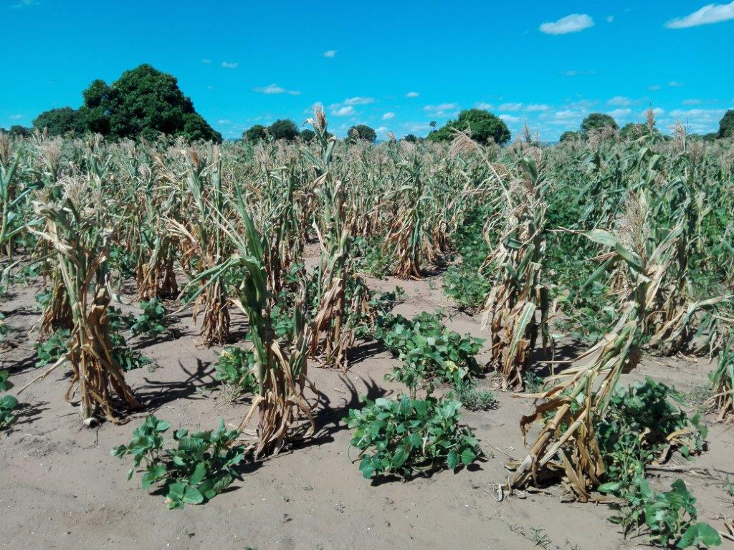

The Lojy Be cowpea control plot. This woman’s control plot here, with no previous plantings of Lojy Be cowpeas, and the experimental plot in the photo below, with six previous years of Lojy Be use, are about 10 m apart. The dark green foliage of the experimental plot can be seen in this photo behind the control plot, in the right-hand third of this photo. These two photos were taken the same day. In fact, the two clouds just appearing at the right of this photo are obviously the same two clouds that have moved just a little more than half-way across the sky toward the left in the second photo. The same very small amount of fertilizer was used in each plot. Even though the maize here has a much lower plant population/ha than the maize in the experimental plot, the maize in this field has tightly curled leaves, a sign of extreme drought stress. Even the Lojy Be, although drought tolerant enough to be quite green, has only formed tight little clumps of vegetation rather than covering all of the soil.
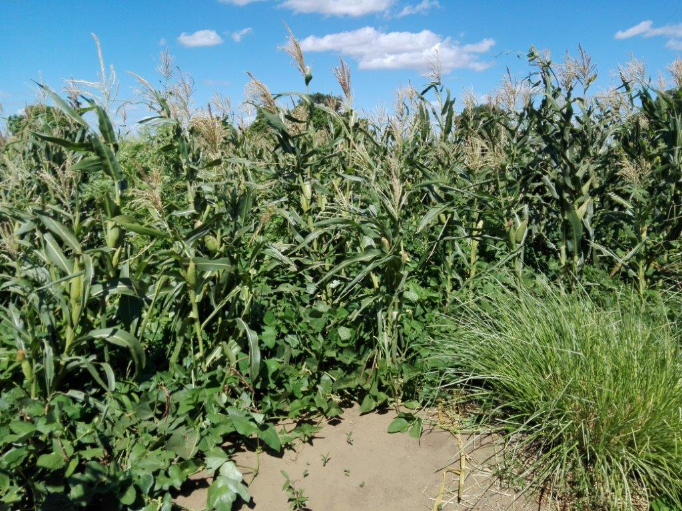

The Lojy Be cowpea experimental plot. The dark green color of the maize here not only indicates that soil fertility has improved dramatically, but its wide flat leaves show it has suffered virtually no drought stress, either, even though it has produced a lot more biomass. The only indication that a drought even occurred are the curled leaves of two hills of maize in the center of the photo where they had to compete for moisture with some previously established vetiver grass. The Lojy Be itself, a crawling, edible cowpea, has completely covered the ground without climbing or bothering the maize. It has thereby maintained moisture in the soil both by covering the soil and increasing its organic matter content. One can also see that outside of the field, the soil is still the same dry, whitish soil seen all through the control plot. Even more remarkable, the drought resistance was achieved without the added complement of any shade from trees.

The increased fertility in this case has brought at least a tripling in the productivity of the maize. The resistance to drought will double that yield differential again; the experimental plot will easily produce over six times the yield/ha of the control plot, in addition, of course, to the

two harvests of high-protein cowpeas. Both the increase in productivity resulting from more fertile soil and that resulting from increased drought resistance are typical of the increases in yields achieved by many other gm/cc species that produce equally large quantities of biomass.

Case #3: Conservation Agriculture, EPAGRI, Santa Catarina State, Brazil

In the mid-1990s, I was facilitating a course in Chile for leaders from governmental agencies across the Southern Cone of South America. One of the more animated participants kept making comments that my years of working with or visiting over 400 agricultural development programs told me could only be a reflection of his having worked in a particularly good program. Suspecting that Valdemar de Freitas’ program was a first-class operation, I pulled him aside one evening, and asked him to tell me more about it. Within minutes, my hunch was confirmed and I was planning a trip to southern Brazil.

Valdemar was the director of EPAGRI, the agricultural development program of the Brazilian State of Santa Catarina. He was running what was easily one of the finest agricultural development programs I had ever seen. We drove for hundreds of km along Santa Catarina’s highways, and during a good part of the time, the farms on both sides of the road were covered in gm/ccs and contour grass barriers like Laureano’s.

Green manure/cover crops are defined as “any plant, whether a tree, a bush, a climbing plant, a creeper or even an alga, that is used by farmers to, among other things, fertilize the soil or control weeds.” They are not usually grown monocropped, as traditional green manures are, nor are they usually buried, and they are almost never chopped down green, because people want the grain to eat, feed to their animals, or use to plant more gm/ccs. Gm/ccs include the one climbing up Laureano’s maize stalks, the cowpeas that have given Madagascar’s fields such fertility and resistance to drought, the gliricidia trees you will read about below, and over 100 other species that farmers are now using somewhere in the world. Many of them, like the cowpeas, double as edible grain legumes. Thus, in addition to building soils and increasing yields year after year, they produce high-protein food for humans and fodder for animals, as well as sequestering huge quantities of atmospheric carbon in the soil. They are, by far, the cheapest way to improve soils and sequester carbon known to humankind. They are the central, unsung heroes of these stories.

The Brazilians, in addition to being the world’s current leaders in the research and adoption of gm/ccs, were also introducing zero or minimum tillage, crop diversification and the use of ground cover. Together, these practices are called “Conservation Agriculture,” another kind of regenerative agriculture.

EPAGRI has been working with CA throughout the State of Santa Catarina since the early 1980s. Together with its sister organization, IAPAR in Parana State, run by Ademir Calegari, it has also spearheaded a movement across Brazil that has resulted in over two million Brazilian farmers and another million Paraguayan farmers using CA on more than 25 million hectares.

Nearly all of these farmers who use CA still use some synthetic fertilizer, though in much smaller quantities than before.
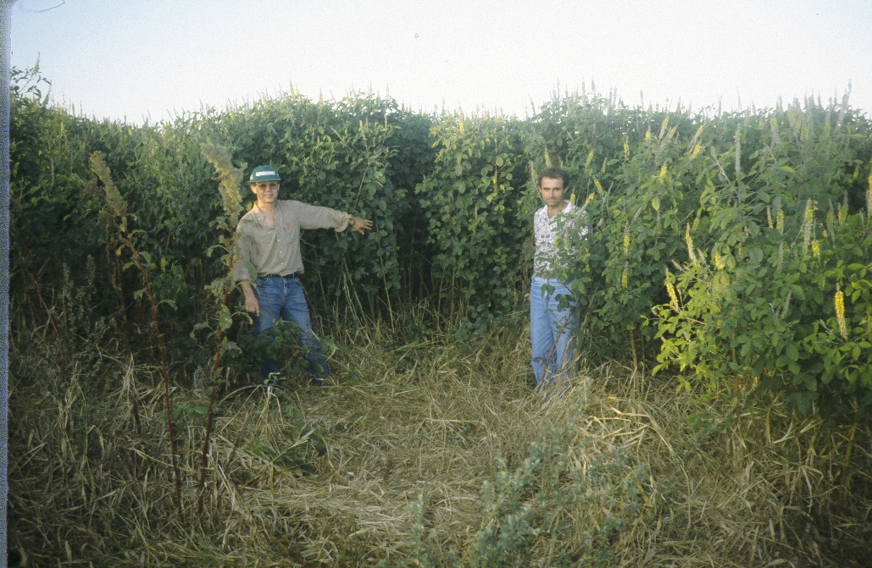
To maximize biomass production and weed control, these medium-scale farmers in Brazil use gm/ccs like this crotalaria, which has produced so much biomass that it has completely hidden from sight the already harvested maize crop with which it is intercropped.

Case #4: Integrated development program, World Neighbors/Oxfam,
San Martín Jilotepeque, Guatemala

When the World Neighbors/Oxfam Integrated Development Program began in San Martín Jilotepeque in 1972, the average smallholder maize harvest in the township of 33,000 mostly Mayan people was less than 0.5 t/ha. At the same time, the township's smallholder farmers only sold at most some fifteen species of crops in the town’s market, including maize, common beans, coffee, cane sugar, oranges, a couple of other fruits and some native herbs.

The Program’s main agricultural goals were to increase maize and bean yields, conserve the rapidly eroding soil, and introduce the idea of a crop rotation instead of growing maize every single year on the same land. When the Program ended ten years later, it had spent a grand total of only US $ 300,000, with half of that dedicated to health, road work and earthquake rehabilitation. Yet fully 3,000 farmers had adopted contour grass barriers and improved fertilization, raising their average yields to over 1.5 t/ha. That’s a total cost of just $ 50.00 (in 1975 dollars) for the agricultural work for each family who sustainably tripled its maize yield. The Program also introduced a kind of field pea as a gm/cc to the area, but since no one knew much about tropical gm/ccs back then, it was a poor choice and failed completely. A crop rotation using maize, beans and wheat had been adopted by something over 600 farmers.

At the same time, the Program taught the farmers the principles of RA, and taught them both to experiment on their own and share what they learned with each other. Thus, they learned to manage both the processes of agricultural research and extension. They had become the managers of their

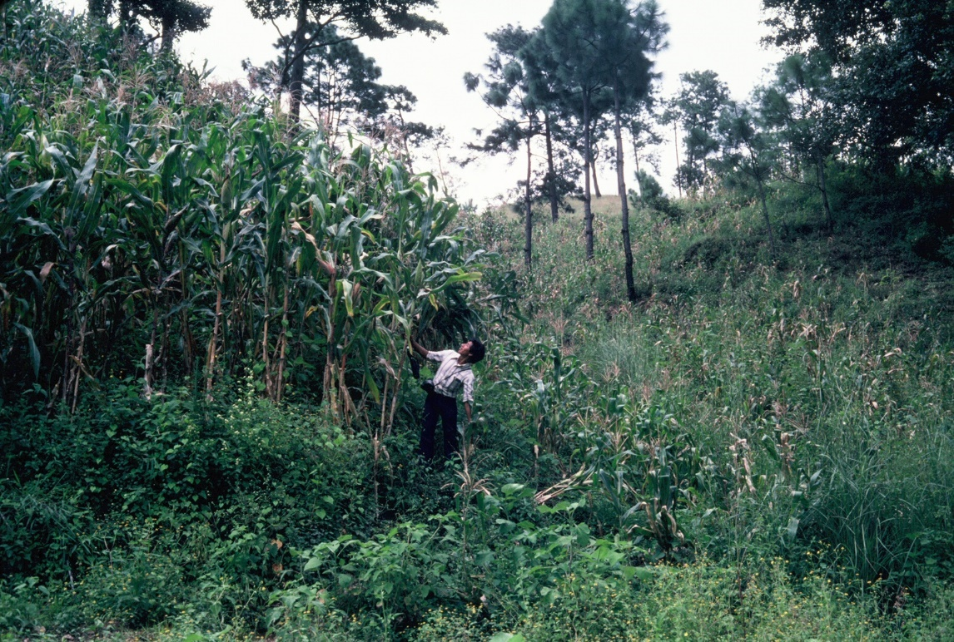
In 1973, producing maize like this was relatively easy: just apply plenty of the right synthetic fertilizer. But by 1976, fertilizer prices had almost tripled. Nevertheless, people in San Martin had already become accustomed to producing good yields. Many tried buying fertilizer, buying animals to use their manure (both were very expensive), or trading the Napiergrass on their contour barriers for manure from large landowners (this provided too little manure). Others started growing high-value fruits or vegetables, which would pay, but only barely, for the labor of composting or the cost of fertilizers. But we didn’t find a way of achieving good yields of basic grain crops cheaply, without excessive labor and without depleting the organic matter in the soil, until 1983, when we began learning more about gm/ccs.

own development process—the “authors of their own destiny,” as Paulo Freire, the great Brazilian prophet of concientización, used to say. Today we would say they had become empowered.

I founded and ran the Program for a year and a half, and have returned occasionally since then. When I returned in 2008, I checked out the Sunday market. Those 3,000 farmers are now producing an average of about 3 t/ha of maize—six times their previous yields. Instead of a dozen species of locally produced foods, I counted 96, including a half-dozen grains, along with over 35 different vegetables, over 30 fruits, and about 15 herbs. According to one outside evaluation, about three thousand farmers are now using soil conservation, zero tillage, the application of compost and animal manure to their soil, and crop rotations. Some have learned to use gm/ccs. Fertilizer use has dropped dramatically. Three “model farms” have sprung up, at which former program participant/leaders have trained farmers from around Central America in regenerative techniques (the numbers of visitors have recently decreased because so many people have already been trained). One of these demonstration farms won an award about six years ago from the national government for having the best model farm in the nation.

In the ’70’s, the vast majority of the Mayan people walked on foot to the Sunday market, some from as far as 20 km, with the women carrying their market goods on their heads. Mayan people rarely ever finished 6th grade. And thousands were trucked to the South Coast to work several months each year on plantations for less than $ 1.00/day. Today, going to the coast is a thing of the past, many young Mayans from San Martín have graduated from high school, along with a few from universities, and people either ride to the market on buses or in one of their Mayan neighbors’ used pick-ups. Whereas about half the young Mayan children had visible signs of malnutrition in the early ’70’s, it’s now a tenth of that.

More important, San Martín’s farmer leaders are training farmers in Mexico, El Salvador and Honduras, as well as Guatemala. Some 35 leaders from the Program, none of whom had achieved a 6th grade education, have worked as well-paid extensionists at different times with some 40 different institutions. Five of them have become program directors for other institutions and three have worked in a total of over 15 nations of Asia and Latin America as consultants, being paid US $ 100 to $ 150/day. Furthermore, soil conservation, zero or minimum tillage and gm/ccs are being taught by development organizations throughout much of Central America.

The example of San Martín illustrates very well three important aspects of RA. First of all, at least for the world’s Laureanos, it is a process more than a destination. Any farm can always become more biodiverse. Most any farm can produce a lot more biomass, thereby producing more organic matter and sequestering more carbon. And many farms that have already made a tremendous amount of progress toward RA’s goals still use a little fertilizer, on one crop or another. The important point is to advance as far along the continuum as possible, and always keep on trying to advance further.

The Dogons represent a very good case in point. After all, they have trees all across their fields. Between all the trees and crops they use, they easily grow 15 different species in their fields in any given year. They never plow the soil, their soil is covered much of the year, and their plants feed heavily from the mulch. They are about as close to imitating a tropical forest as anyone has ever gotten while still producing basic grain crops.

But even the Dogons are not ready to quit innovating and advancing.

The second aspect is that most of the world’s farmers who use RA will go on innovating and advancing, for decades, as they have in San Martín. They do so because, as they become aware of all the benefits these techniques can bring, they want to enjoy more and more of them.

The third is that there is never going to be any one single regenerative farming system. There are now, in San Martín, almost as many different farming systems as there are RA practitioners. We can teach people the basics of RA, but we won’t ever know how they will eventually apply them in the best possible ways.

Case #5: The world’s cheapest maize, Honduras, Guatemala and Mexico
In about the 1920’s, the United Fruit Company brought mucuna (also called velvetbean) to Central America to feed the mules they used for carrying bananas out of their fields. We don’t know where or when smallholder farmers began using that mucuna as a gm/cc, or how it spread from one country to another. Nevertheless, totally because of spontaneous spread from farmer to farmer, today an estimated 25,000 farmers use the maize/mucuna system. It is common across about half the northern coast of Honduras, in El Petén of northern Guatemala, and along the east coast of Mexico from the western edge of the Yucatán Peninsula most of the way up to the tip of Texas.

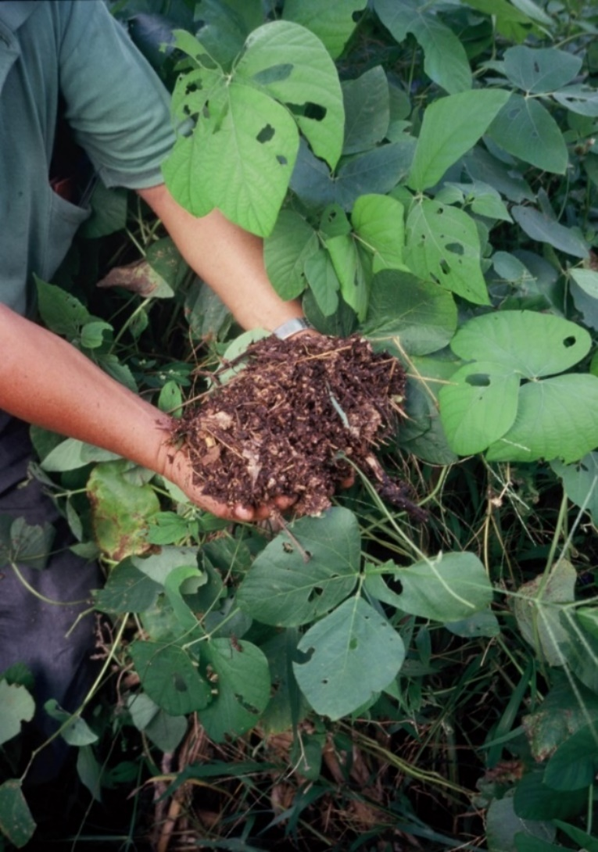
This is the topsoil from a typical field in the maize/mucuna system after having produced maize every year for 40 straight years. It looks like this down to a depth of at least 35 cm. Many scientists in conventional agriculture argue that soil fertility improvement over time is impossible without the use of synthetic fertilizer. This experience, like that of literally millions of farmers around the world, proves that idea to be totally false.

Furthermore, this soil absorbs water like a sponge--so much so that even on 30% slopes and in areas where the annual rainfall is well above 2,000 mm, there is no rainwater erosion.

The green leaves in the photo are the leaves of the mucuna. We don’t worry about a few perforated leaves on gm/ccs. That just means that insects are already composting some of the biomass for us.

The source of the maize/mucuna system’s popularity is no secret. It is easily the simplest, and very likely the cheapest, way to grow maize ever devised. This system works only in very humid areas, where total rainfall is well above 2,000 mm/year and it rains all year long. During the wettest part of the year, when no food crops can be grown anyway under the torrents of rain, the mucuna completely covers the field. It protects the soil from erosion because of its complete cover, and produces huge amounts of biomass that, instead of allowing the nutrients to be washed away, recycles them through the mulch about as fast as any system except the humid tropical forest itself. Then, when the rain calms down a bit in December, the mucuna dies and the farmers immediately plant their maize. Within a month or so, the mucuna reseeds itself and starts growing again. Together with the mulch, it completely controls the weeds. In another three or four months, the maize is harvested, the mucuna completely covers the field again, and the cycle repeats itself.

The system requires no machinery, no synthetic fertilizer, and no agricultural chemicals. In fact, it requires no inputs of any kind, except some maize seed from the previous year’s harvest. There’s no need to do soil conservation work, apply fertilizer, make compost, till the soil or bury the mucuna, and usually no need to cut down more than an occasional patch of it. One only needs to weed part of the fields in the rare case that the mucuna did not manage to reseed some patches and therefore left them uncovered. By and large, the only work required is to plant the maize and harvest it. That’s all. Many conventional scientists claim that regenerative and low-input agriculture inevitably require more labor than using chemicals. Hundreds of farming systems put the lie to that little myth, but none as dramatically as the maize/mucuna system.

The maize/mucuna system produces about 30% less maize/ha than the heavily mechanized, heavily fertilized maize fields on the flat land below, but its costs are so low that each bushel of maize is about 25% more profitable than is that of the conventional farmers. And it does this without constantly mining the organic matter out of the soil (thereby destroying much of its natural fertility). Nor does it pump carbon dioxide into the air through the manufacture, transport, and application of synthetic fertilizers. Quite the contrary: it is regenerating the soil every year, until the soil has something on the order of a 12% organic matter content, according to soil analyses. Thus, it is sequestering more carbon in the soil than any other widely used system of producing basic grains anywhere in the world.

So why is this system so efficient and so sustainable?

A group of people I worked with in a Honduran non-governmental organization called COSECHA, decided in the early 1990s that we needed to find out what kind of agricultural systems would be most sustainable in the world’s tropics. We had been trying to follow the recommendations of textbooks from the temperate world, but they were sending us in one wrong direction after another. These books told us that intercropping did not work, when it was clear from fields all around us that in the tropics, it offered significant advantages. They described how to make hay and silage for our animals to feed them when the ground was covered by snow, but we had no snow. Furthermore, making hay was no use at all when we could grow green forages the year round. They recommended machinery our farmers could never afford, to do jobs, like plowing, that damaged our tropical soils. It went on and on.

Gradually, during 12 years of traveling across Latin America to visit the continent’s most innovative programs and many of its most profitable farmers, we developed a list of five simple
principles for a sustainable, regenerative tropical agriculture:

- Keep the soil covered,
- Minimize or eliminate all soil tillage,
- Maximize biomass production,
- Maximize biodiversity, and, strangest of all,
- Feed the crops through the mulch.

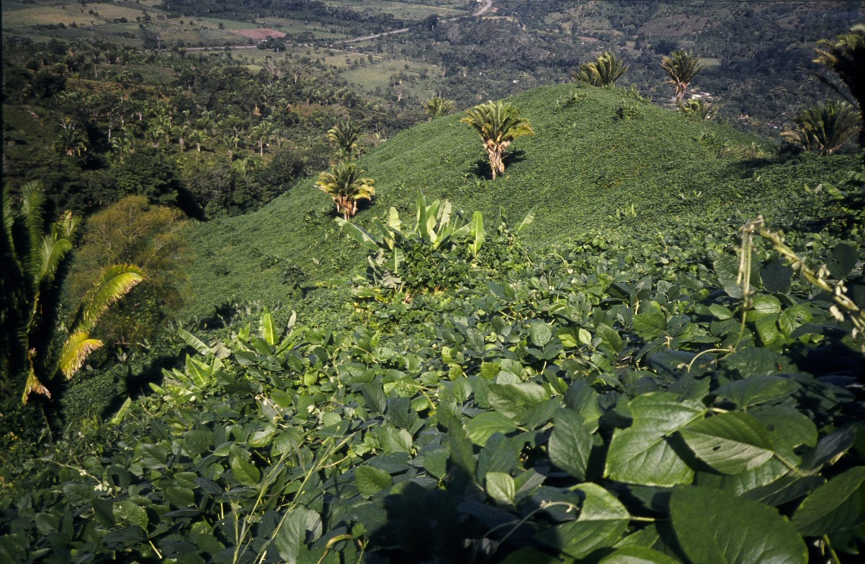
The maize/mucuna system covers many thousands of hectares of smallholder land in each of Mexico, Guatemala and Honduras. Except for a handful of false banana weeds, the half-dozen farms on this hillside are completely covered by non-stop mucuna. The conventional system on the flat land in the background, using fertilizer and tractors, is a good deal less profitable.

Then one day, a year or so later, we were musing about the way these principles fit so well together. For instance, when there’s a lot of biomass and you don’t plow the soil, the soil is automatically going to stay covered. Suddenly it hit us that these principles perfectly described the way a tropical forest works. Had we realized that earlier, we could have saved ourselves many months of work over those 12 years.

After all, nobody has to go out and plow a tropical forest every year, nor does anyone have to spread a mulch across it. Tropical forests have produced huge amounts of biomass for millions of years on some of the world’s poorest soils. How have they managed that neat little trick? By producing a tremendous amount of biodiverse biomass, and then feeding those nutrients to their trees and bushes through the mulch (called a “litter layer” in forestry). This cycle works so fast that these nutrients produce several times more biomass/gm of nutrients/year than they do in conventional agriculture. And the nutrients never touch the soil, where many of them would be immobilized and lost to the system. Yes, feeder roots don’t have to feed from the soil, any more than they do in hydroponics. And they don’t always grow downward. Feeder roots will all happily grow upward if that’s where dinner is being served.

The maize/mucuna system is both efficient and sustainable because it follows most of these rules very well. It still has a good way to go to reach maximum biodiversity, but it is one of the best biomass producers one will ever find. It keeps the soil covered completely year-round. It requires no tillage, ever. And it feeds its crop through the mulch. No wonder it produces better and better yields for decades until it reaches a plateau four times the national average for smallholder farmers, with only a vastly more fertile soil to show for its efforts. And no wonder it is so sustainable.

A recent, rather surprising discovery is that the five principles for achieving sustainability in tropical agriculture may well apply to more than just the tropics. Experiences like those of Gabe Brown in North Dakota and Christine Jones in Australia, developed in part with an assist from the same Brazilians who taught us, are showing that at least the first four principles can result in more profitable farms in developed nations. We still need more evidence, but the convergence of practices in these two very different settings may be more than just an astonishing coincidence.
Case #6: Micro-terraces, World Neighbors,Guacamayas, Honduras

The Cantarranas Program started in 1983 and ran for about 10 years. It involved over 20 villages, but Guacamayas was admittedly the star of the show. An old mining area with no land anywhere at less than a 25% slope, Guacamayas' soil was washing down the river at a tremendous clip. The Program taught the people how to make very simple irrigated micro-terraces, and now absolutely every one of the 70 families in the village is using them. The terraces are now managed with zero tillage, the fertilization of the vegetables is done entirely with coffee pulp from the people’s nearby coffee fields, and about 20 different vegetables are grown and sold to supermarkets in Tegucigalpa. Some of the farmers have gone totally organic.

Most of Guacamayas’ coffee fields follow all five of our principles, but applying these principles to vegetable production has been more challenging. The micro-terraces enjoy excellent biodiversity and after two or three years, when the organic matter content of the soil has been improved, they are never plowed again. But soil cover and biomass production are still deficient. Probably the next step in that direction would be the use of intermittent shade, Dogon-style.

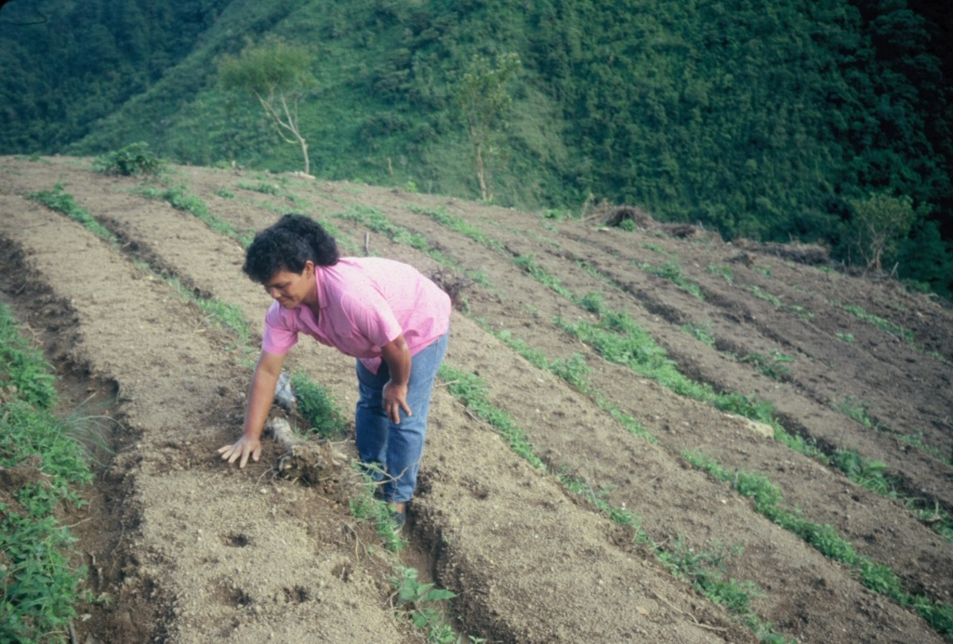
This woman’s micro-terraces allow almost no erosion because any excessive rainwater flows along the micro-terraces at only a 0.5 % slope. Maintenance costs for micro-terraces are fairly high, so they are usually only used where people raise high-value crops and have access to good markets.

Micro-terraces can work well on slopes of up to 60%. The field in the photo below, and many others just like it, produce some of Honduras’ finest vegetables. Carrots are growing in the lower foreground, coffee in the background. Although these micro-terraces look rather fragile, they withstood Hurricane Mitch perfectly well, while some of the facing unfarmed hillsides
suffered from major
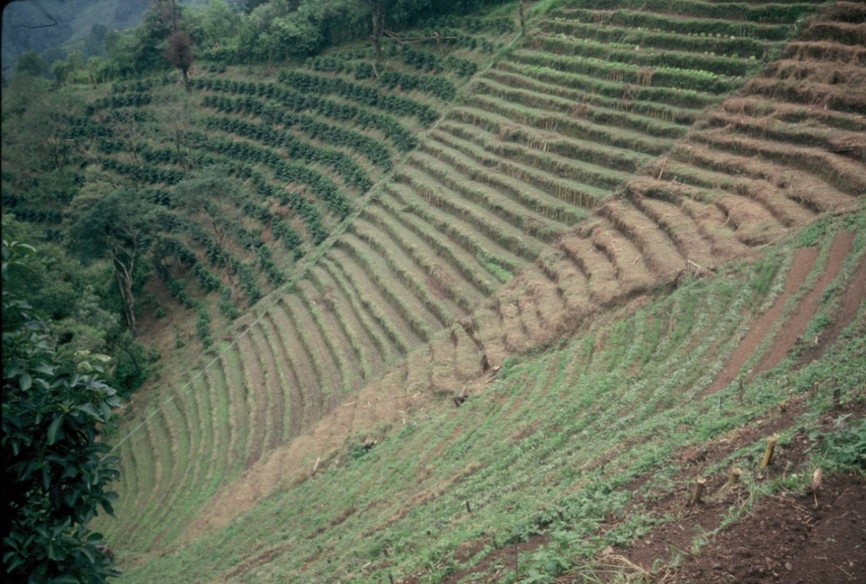
landslides.

The idea that “arable land” must have a slope of less than 10% has thus become seriously obsolete. Many millions of the world’s people would starve if they could not farm hillsides steeper than 10%.

Case #7: Tephrosia fallow, Bamenda, Cameroon
One day a smallholder farmer was walking to market in the town of Bamenda, when some beautiful flowers caught his eye. He gathered a few seeds to plant in his garden back home in the village.
After a year or so, he noticed that the soil under this plant, called tephrosia, had become really fertile, so he guessed it might do the same for his fields. People in this area of Cameroon still have enough land so they can use a four-year natural fallow. Customarily, they let the natural vegetation grow on their fields for four years, so it will increase the organic matter in the soil. Then they plant rice, their most valuable crop and the one that demands the most fertile soil, when the field is most fertile. They plant maize the second year, and the third year, when the fertility is largely spent, they plant cassava, which is very resistant to poor soils. The following year, they start letting the natural vegetation restore the soil again.

Our smallholder experimenter waited until the natural fallow was to start growing, and scattered some tephrosia seeds all over the ground. Sure enough, the tephrosia grew 2 m tall, and within one year, he was amazed to find that the soil was just as fertile as after four years of natural fallow. This meant that he could plant crops on his field for three years and then only fallow it one year. Instead of only being able to plant crops on a piece of land three out of every seven years, he could now plant his crops there three out of every four years. In effect, he had nearly doubled the amount of his land he could crop every year.

Another of the many advantages of gm/ccs is that they are very noticeable. None of our friend’s neighbors could help but notice that he was growing this silly 2-mt-tall flowering bush in his field when it was time to fallow it, or that he was able to cut those bushes down after only one year and produce a good crop of rice again. So they started walking off with a little of his seed to plant their

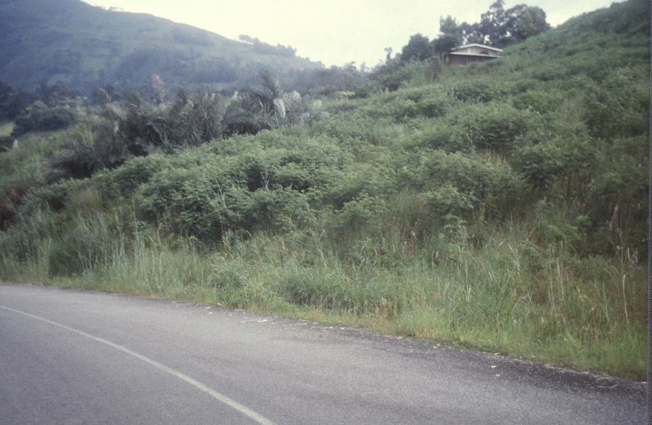
All those 2m-tall bushes in the center of the photo are tephrosia. The impressive spontaneous spread of the tephrosia-based improved fallow system from one farmer to over 2,000 in just 15 years stands as a monument to the innate popularity and potential of simple regenerative agriculture systems.

own “improved fallows.” By the time I visited Cameroon eight years later, over 1,000 farmers were using the tephrosia fallow. A few years ago, I received news that there were over 2,000 farmers doing it. No outside program was ever involved, nor even much of a process of farmers teaching farmers. The technology spread mostly by example.

This sort of spontaneous spread is what we need to get the world’s Laureanos moving toward RA just as soon as possible. We need very simple, visible, inexpensive, minimum-labor, easily understood and easily copied technologies that provide very obvious, significant, desirable and short-term but lasting benefits. When we find such technologies, they will propagate themselves. No outside program helped spread the tephrosia fallow to over 2,000 farmers; it grew legs and walked across the landscape by itself. In fact, smallholder farmers in Thailand and Vietnam, also on their own, have developed and spread almost identical tephrosia-based improved fallows.

Of course, some day the people around Bamenda will not have enough land to fallow it even one year. Then, they could intercrop the tephrosia with either their maize or cassava, and thereby avoid ever fallowing at all. I mentioned that possibility to some of the farmers when I was there. Very likely, this idea has also grown legs by now. After all, if smallholder farmers were dumb, a large percentage of them would have died of starvation a long time ago.

Case #8: Famine prevention, ten African nations
In 2009, the development organization World Renew asked me to do a six-nation study of agricultural work in Africa. So, one day in September, 2009, I found myself sitting next to the village chief and his elders in Koboko village, Malawi. In front of us, 30 women and their children were gathering under a huge shade tree, the traditional site for village meetings. Having been told that a strange white man wanted to ask them some questions, they were gradually squeezing together on an assortment of hand-woven mats and tiny rough-hewn chairs.
I began my little interrogation with the one question I ask more often than any other: “What is the most important single problem that prevents you from having enough food to feed your children?” Without even waiting for one of the village’s male authorities to answer, one of the taller women spoke up: “Our soil is tired out. And it is getting worse every year.”
Before she had even finished, four or five other women chimed in, “Yes, what she said is true!”
“Last year I harvested 35 bags of maize. But this year I only harvested 27, even though it rained well.”
“We no longer have any way to keep our fields fertile.”
“Our soil has become so hard that even when it rains, the water just runs off.”
When things had quieted down again, the village chief, calmly and authoritatively, put his stamp of approval on the obvious consensus by voicing his heart-felt agreement.
Frankly, I was totally taken aback. Just five years earlier, Malawi had suffered one of Africa’s worst droughts ever. People were so hungry they were cooking up and eating the bark off of trees. Many died, and millions more would have if food aid hadn’t been distributed throughout the country. Yet in this village, everyone concurred that soil fertility was a worse problem than droughts. They explained that, sure, the drought had been horrible, but droughts only occurred once every five or ten years. Soil fertility was threatening to destroy their food supply permanently—forever.
The women were absolutely unanimous. They were adamant. And they were obviously scared. Even though they were desperately poor, they had never before faced such a long-term and apparently insoluble threat to their very survival.
Everywhere I went in lowland, drought-prone Africa, the answer was the same. Harvests were decreasing from 10 to 20% every year. But why were they facing such a crisis, and why for the first time?
The fact was that they were being hit by a perfect storm of unprecedented problems. First, unlike in Cameroon, they no longer had enough land to even fallow it for one year, much less four. The traditional 10- to 15-year fallows had been the technology African farmers had used for 3,000 years to maintain their soil fertility. But population growth had meant their family farms were now less than 2 ha in size. A family can’t fallow ¾ of a 2-hectare farm and still grow enough food to survive. So fallowing across sub-Saharan Africa was in its death throes. Using fertilizer to maintain their soil’s productivity was also out of the question because wealthier countries had used up most of the world’s cheap energy, and the manufacture of nitrogenous fertilizer requires a tremendous amount of natural gas. Synthetic fertilizer was now too expensive to be profitable on their depleted soils. Lastly, global warming was making rains more and more irregular, once again reducing their farms’ productivity.
Every one of these problems was new, and was hitting them for the first time in history. And the crisis was as life-threatening as it was unprecedented.
As a result of my study, I wrote a chapter for the book State of the World 2011. In that chapter, called “Africa’s Soil Fertility Crisis and the Coming Famine,” I predicted that “tens of millions of people” could face, “within the next four or five years...an imminent tragedy: a Great African Famine.”
That tragedy is now upon us. Just over a year ago, in early 2017, the United Nations officially declared that a famine was stalking Africa. Thirty million people, from West Africa, East Africa, and southern Africa, were in extreme danger because of a major drought. The United Nations called it “the largest humanitarian crisis since World War II.” Luckily, and something I had failed to foresee, disaster relief efforts sprang into action, and few deaths have occurred so far.
But food aid organizations assume that famines are self-terminating. When the rains fall again, the drought ends. Thus, they figure this drought will soon end and they can then use their now heavily depleted food supply in the next inevitable disaster somewhere else.
Today, however, well over 40 million people in Africa are facing the possibility of starvation. What the food aid people don’t realize is that this famine was not caused by a lack of rain. It is occurring, year after year, because without organic matter, the soil becomes hard. The infiltration of rainwater into the soil has dropped from around 60% to less than 20%. I have gone out into numerous fields in the Sahel right after a three- to four-hour tropical downpour. When I dig down into the soil, it is only moist down about 3 cm. Not only is that too little moisture for crops, but being so close to the surface, most of it will evaporate in a day or two. Three days after a heavy rain, the drought resumes.
This means that this African drought is not going to end the next time it rains. It will go on and on, with short remissions, until the continent’s farmers change their agricultural practices. And that is not going to happen this year or the next. When the drought goes on year after year, the food aid agencies will find themselves with nowhere near enough food to cover this disaster along with the usual array of others.
Realizing this, and realizing that gm/ccs were by far the easiest, cheapest, and most widely appropriate technology on the shelf for ending the famine, I moved to Africa in 2011. I knew I couldn’t single-handedly prevent the Great African Famine, but perhaps I could get a head start on the process. My goal was to get a good gm/cc system either identified or started in each of ten of the lowland, drought-prone countries where I had predicted the famine would hit. I hoped, in each case, to identify or create a system that was widely appropriate, and carry the process along far enough that the gm/cc system had proven itself because village farmers were spreading it spontaneously.
The famine has begun. I had predicted not only its starting date by within a few months, but also accurately predicted that it would be most severe in Africa’s sub-humid and semi-arid lowlands. With the generous support of four large international non-governmental organizations--the Canadian Foodgrains Bank (CFGB), Oxfam, CARE and most of all, Catholic Relief Services (CRS)—we have succeeded, as of the middle of 2018, in reaching my goal. We now have functioning, spontaneously spreading gm/cc systems in twelve countries. In two of these countries, systems already existed and I merely found and identified them. In three other countries, a system was already established and well-known, while in seven additional countries, I’ve helped either develop or spread new systems.
The two gm/cc systems that already existed but were unknown elsewhere are those of the Lojy Be cowpea in Madagascar and the tephrosia fallow in Cameroon, both described above. The three countries where a system was already widely known were Niger, Senegal and Burkina Faso, where FMNR, described below, had been developed and spread by Tony Rinaudo. The systems I have helped develop or spread include the dispersed shade system in Mali, also described below, a system in which edible lablab beans are intercropped with maize in Tanzania, Rwanda and Uganda, a system (already developed by Sebastian Scott) using ratooned pigeon peas intercropped with maize in Zambia and Malawi, and in Mozambique a system using 60-day cowpeas that can be intercropped with almost any other crops because they have been harvested before the other crops ever need the space.
My plan was that when the development community realizes that soil conditions, rather than rainfall, are the true villain of the tale, they will have a proven example of what they can do to solve the problem, right in the same country in which they are working, or at least nearby.
In the last six months, I have realized that the vast majority of the development community has still neither realized the real causes of Africa’s increasingly frequent droughts (now every second or third year in many areas), nor reacted by doing something about it. In response to this sad fact, I have started working with a group of friends to spread gm/cc across 1/4 to 1/5 of four African nations over the next five years. Our long-term goal is that eventually this program, called Better Soils, Better Lives, will be able to sustainably double the productivity of about 70% of all of sub-Saharan Africa’s lowland farmers within some 30 years—thereby ending hunger in most of Africa.
Time will tell.
Case #9: Dispersed shade, Oxfam, Mali
By 2010, Oxfam had organized about 300,000 women into over 12,000 savings groups spread out over the length and breadth of Mali. Oxfam’s Jeffrey Ashe soon realized that these groups could serve as a wonderful platform for an agricultural program, and asked me to manage the process.

I decided that a gliricidia-based dispersed shade system would be the first technological option I would propose to the women. Such a system not only had real potential for use throughout the drought-prone lowlands of Africa, but had never been tried in Africa before.

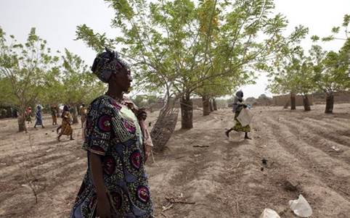
Members of a Malian women’s group walk through their plot of gliricidia-based dispersed shade roughly two months before the rainy season will start. Note the ridges used for planting row crops under the trees. The bare ground shows that these trees are obviously providing the only fodder available for cattle at this time of year. The trees in this photo have not been pruned as much as they should be for use as dispersed shade because the women are more interested right now in making money by selling the trees’ very valuable seeds—to scores of spontaneous adopters.

Dispersed shade works on the same principle as intermittent shade, except that instead of creating patches of heavy shade that move across the field, one aims to produce a lighter shade that covers all the field evenly. Research in Australia and Honduras, as well as widespread farmer experience, indicates that maximum crop production can be achieved with something between a 15 and a 50% shade.

Dispersed shade is a traditional practice in many parts of the developing world, but often we can help improve these local systems. One of the most promising improvements consists of using mother of cacao, or gliricidia trees. These trees provide an impressive list of advantages: a) they grow very quickly (the trees in the photo above are only four years old!), b) they can be propagated by seed, seedlings or cuttings, c) their flowers are edible and are commonly eaten in Honduras and El Salvador, where the tree is native, d) their leaves are one of the three or four best tree leaves we know of for fertilizing the soil and raising crop yields, e) they withstand heavy annual pruning, which one can do while standing on the ground, f) their leaves are an excellent dry season cattle feed, g) the wood can be used as firewood, h) the tree is very resistant to drought, even in its first year, and i) the bark is an excellent rodenticide (although, as with all rodenticides, it must be used with extreme caution).

A previous program in northern Mali had already tried growing gliricidia trees, and had found the trees were amazingly capable of handling the harsh environment. Furthermore, they were very popular among the villagers because the trees’ leaves started growing about two months before the rains came (as in the photo above). This was precisely the time when, after a bad rainy season, people’s cattle started dying off for lack of fodder. But anyone with gliricidia trees could just cut down a few branches every day and let the cattle eat the leaves. The people christened it “the tree that saves our animals.” Pretty soon, other smallholder farmers were buying gliricidia seeds for as much as $ US 5.00/kg!

Gliricidia leaves are not, however, very palatable. We had always seen this as a serious disadvantage. But across the Sahel, it turns out to be a blessing in disguise. Some people who felt that gm/ccs would never work in droughty areas argued that farmers would always prefer to use the gm/cc biomass to feed their cattle rather than leave it on the soil. They are right—with one exception. Since gliricidia leaves don’t taste very good, once the rains come the cattle abandon them in favor of the tender new grass that is sprouting everywhere. By the time the crops need the organic matter, farmers are plenty happy to use all the newly sprouted gliricidia leaves to feed their soil.

When the women in the savings groups realized that the gliricidia trees could both fertilize their own vegetable gardens and keep their husbands’ animals alive, they became very enthusiastic about the idea. In each of 100 villages, the women’s groups were given half a hectare to experiment with gliricidia-based dispersed shade. They planted the trees in the group’s field, made wicker protections for each tree, and decided to plant a few extra seedlings in their own gardens to shade and fertilize their vegetables. They also planted other crops of their own choice under the trees.

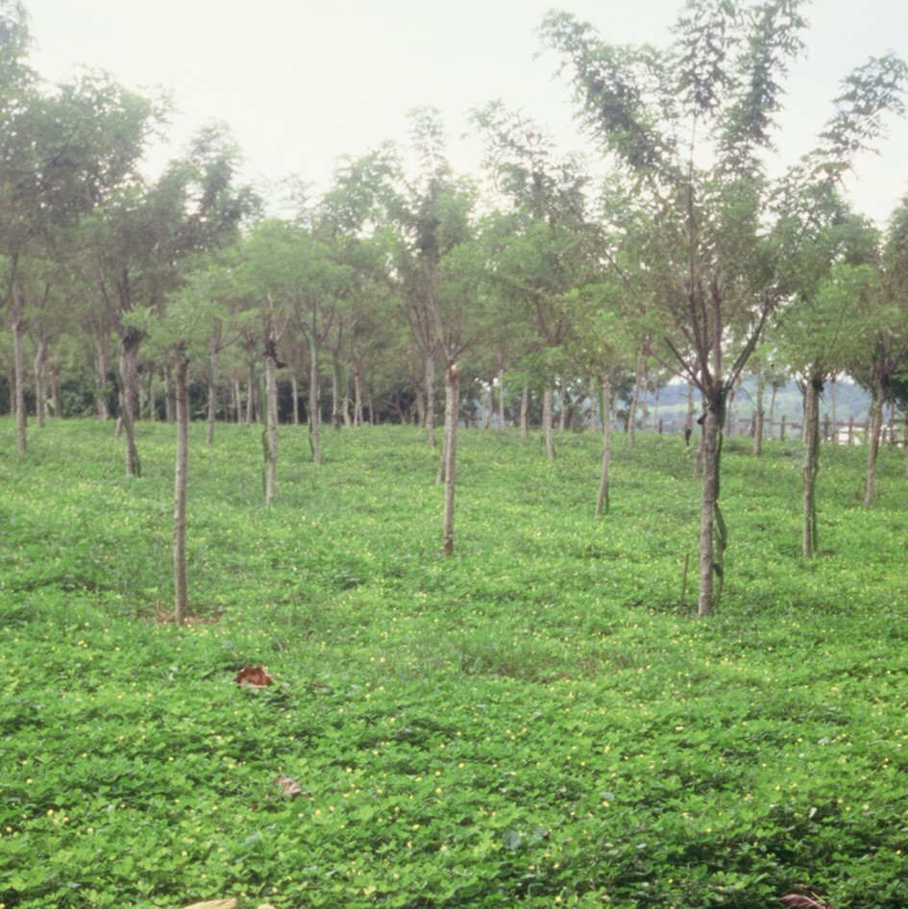
These gliricidia trees in Mexico are serving both as dispersed shade and, in only three or four cases until they grow larger, as tutors for the main crop, vanilla.

The cover crop is perennial peanut (Arachis pintoi), another gm/cc that will provide a moderate amount of additional fertility and is one of the tropical world’s finest cover crops. This field has not been weeded in four years, yet it has no weeds. Furthermore, the perennial peanut does not cause problems by trying to climb the trunks of the trees or the vanilla.

Satisfaction with the trees is still very high in all those areas with at least 400 mm/year of rainfall. In areas of less rainfall, some of the trees have died because of termites. Luckily, in these areas, farmers can use the FMNR system described below.

Easily the most universally overlooked advantage of dispersed shade is that by lowering the ambient temperature by about 10˚ C., it creates an environment in which nitrogen burn-off (called “volatilization”) is no longer a real problem. This means that food legumes planted all over Africa, such as peanuts, cowpeas and mung beans, could, for the first time in most tropical lowlands, contribute significantly to long-term soil fertility. Over the long haul, this advantage could well become the single most important benefit of dispersed and intermittent shade systems in Africa.

Case #10: Farmer-managed Natural Regeneration of Trees (FMNR), ten African nations
Tony Rinaudo, an agronomist working with Serving in Mission, had been working for years trying to plant trees in Niger. This was an important effort, in part to slow down the encroachment of the Sahara Desert, and in part to provide local people with a drought-proof income from the sale of firewood and timber. Until 1983, he had had no luck at all. Plant nurseries failed because they require water just before the beginning of the rainy season, at precisely the time of year when it is most scarce, or because the tender seedlings could just not survive under Niger’s severe, semi-desert conditions. Growing trees from seed made them even more susceptible to drought and excessive heat.
Finally, one day, after years of fruitless effort, Tony was looking out across the dry, barren landscape, thinking about what he could try to do next, or whether he should just give up. Suddenly, he noticed a little green tree sprout in a nearby field that was trying to get a start. Then he noticed another one a few feet away. And another!
What Tony discovered that fateful day not only exists all over Niger, but in most of the drought-prone areas of the tropical world. In these areas, there exist whole “underground forests” of tree roots, barely visible stumps and dormant seeds that farmers have, for generations, cut off, burned, or covered with soil in order to plant their crops. But these almost invisible underground forests are still alive. Tony simply needed to give them a chance to grow. He tried it. The result: in a few years—rather quickly, because the trees already had full-grown root systems—Tony had a forest.
To make a very long story short, together with World Vision/Australia, with which he now works, and dozens of other organizations that also recognized the tremendous new hope in Tony’s discovery, about 6 million previously barren hectares of Niger have been reforested. That sounds unbelievable, but Tony has satellite photos to prove it.
Tony is a wonderfully humble fellow. He would never say what I am going to say here. But his “Farmer-Managed Natural Regeneration” (FMNR) revolution is very likely the most astonishing, least expensive success in the whole history of agricultural development. Even more unbelievable, it was achieved in what is easily one of the most, or perhaps the most, hostile environment for agricultural development on the face of the earth.
All farmers have to do to adopt FMNR is to select the trees they most want to have in their fields, stop burning and cutting these trees, protect them from free-grazing animals and bush fires for a year or two, and prune them so their new trees will have five stems or fewer and don’t produce too much shade for their crops.
This last ten years or so, Tony has been spreading FMNR across the rest of Africa and beyond. US Geological Survey results show that today, in addition to Niger, there are another nine nations from Senegal across to Ethiopia and south to Malawi with an estimated total of 17 million hectares under FMNR. Some of this FMNR adoption has been achieved by smallholder farmers who discovered FMNR independently on their own, in a few cases apparently even before Tony did. By far the largest part of it has resulted from spontaneous spread among farmers themselves from areas where it was originally introduced by development programs.
Large-scale, independent studies of FMNR have now verified that organic matter levels in the soils have improved, farmers’ crop yields have increased by an average of about 50%, and incomes have doubled because of the added sale of firewood. But most important, Niger’s smallholder farmers have begun experimenting with new crops and animals they can raise now that their soil has become more fertile and moist and the trees’ shade protects the land from the hot Sahelian sun.
Regenerating soils is therefore an example of what we call a “foundational technology.” If you bring in a new variety of maize, that is only going to help farmers produce more maize. On the other hand, if you teach farmers to regenerate their soil, you can improve absolutely everything they might do on their farms. In modern terms, gm/ccs can create a “platform” that allows farmers to begin doing all sorts of new things. Besides allowing them to grow new crops and animals, FMNR, for example, can allow farmers to develop new activities that will increase their incomes, increase their biomass production, improve the biodiversity of their farms, and provide more food for hungry nations. At the same time, they will be sequestering more carbon, not only in the soil but in all those newly flourishing, age-old trees.
Just as San Martin’s farmers went from producing 12 to 96 different species of crops well after the outsiders left, hundreds of thousands of African farmers are starting to build on Tony’s FMNR platform to diversify their crops, as well as their economies and their environment.
Many more new case studies are in the making.

